**Experiment No: 10 Date:**

**DISTANCE VECTOR ROUTING**

**AIM:** Construct a network with at least 6 routers connected with a suitable topology where each network connected with 5 Pc’s. Implement RIP (Routing Information Protocol) also known as Distance Vector Routing Algorithm.

**THEORY:**

**Introduction to Routing Information Protocol (RIP):**

Routing Information Protocol (RIP) is one of the oldest distance vector routing protocols used in computer networks. It is designed to determine the best route for data packets as they travel through a network of interconnected devices. RIP operates by exchanging routing information between routers, allowing them to build and maintain routing tables that dictate the paths packets should take to reach their destination.

**Advantages of RIP:**

1. **Simplicity:** RIP is relatively simple to configure and deploy, making it suitable for small to medium-sized networks with straightforward topologies.
2. **Low Overhead:** RIP generates minimal network traffic because it only exchanges routing information periodically, conserving bandwidth.
3. **Compatibility:** RIP is widely supported by network devices and is compatible with both IPv4 and IPv6, making it versatile for various network environments.
4. **Ease of Troubleshooting:** With its simplicity, RIP is easy to troubleshoot, making it ideal for network administrators who need to quickly identify and resolve routing issues.

**Disadvantages of RIP:**

1. **Limited Scalability:** RIP's reliance on periodic updates and its maximum hop count limit (15 hops) make it unsuitable for large or complex networks where scalability is essential.
2. **Slow Convergence:** RIP's convergence time can be slow, especially in networks with dynamic changes, as it takes time for routers to propagate updates and adjust routing tables accordingly.
3. **Routing Loops:** Due to its distance vector approach, RIP is susceptible to routing loops, where packets circulate endlessly between routers, causing network congestion and inefficiency.

**Real-World Application of RIP:**

RIP was commonly used in small to medium-sized networks, such as corporate LANs, during the early days of networking. While its usage has declined in favor of more advanced protocols like OSPF and EIGRP, RIP still finds application in certain scenarios:

1. **Legacy Networks:** RIP is still found in some legacy networks where the infrastructure hasn't been upgraded or where the network topology remains simple and stable.
2. **Education and Training:** RIP is often taught in networking courses and used in lab environments to help students understand fundamental routing concepts due to its simplicity.
3. **Backup or Redundant Paths:** In some cases, RIP may be used as a backup or redundant routing protocol alongside more robust protocols. It can serve as a failover mechanism in case primary routing protocols fail or experience issues.

**Example:**

Consider a small office network with eight routers interconnected as follows:

Each router is running RIP to exchange routing information. Initially, all routers have identical routing tables indicating the shortest paths to reach different network destinations. As data packets traverse the network, routers periodically exchange routing updates to ensure that routing tables remain up-to-date. If a link or router fails, RIP will converge to find an alternate path for data packets to reach their destinations, albeit with potential delays due to its convergence time.

Representation of a Network with RIP protocol

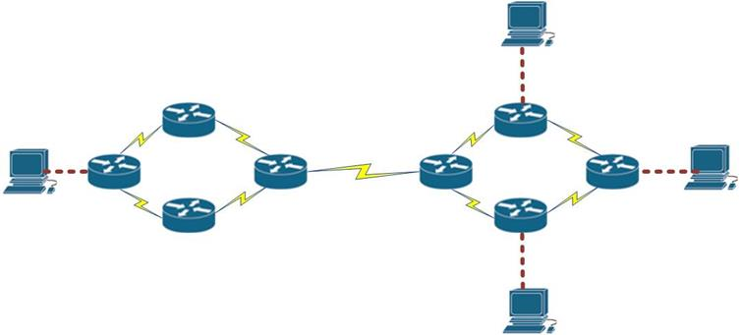

**Network Structure for Dynamic Routing Protocol**

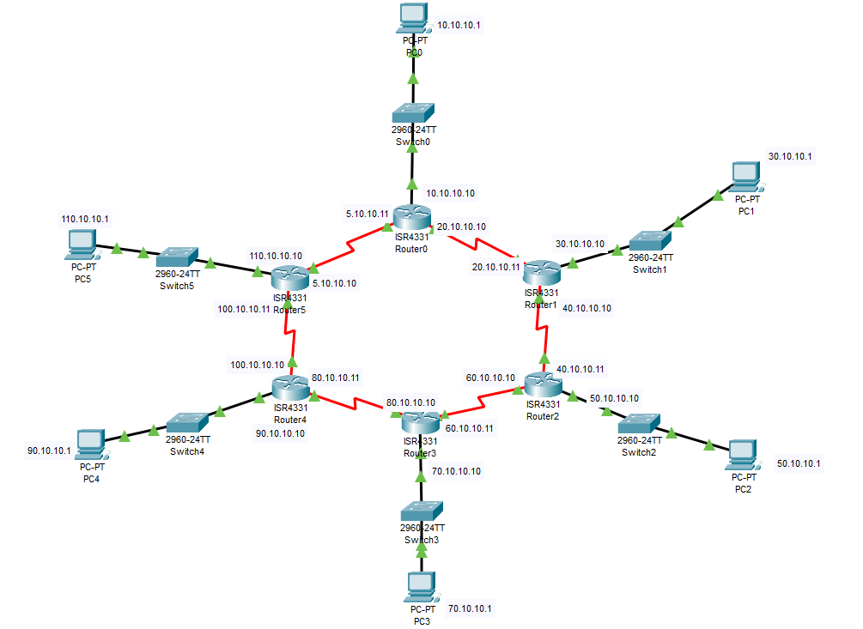

**Configuration of Router (Gigabit Port used For End Device)**

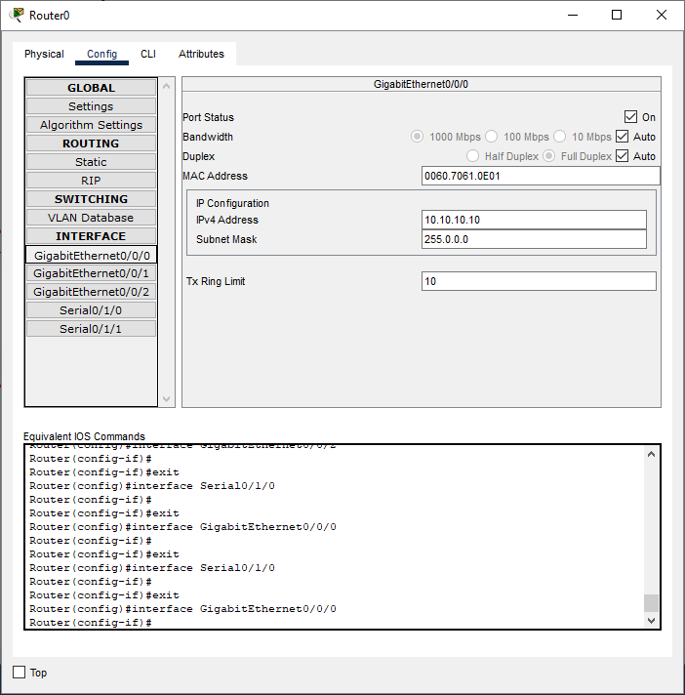

**Configuration of Router (Serial Port used for connecting with other routers)**

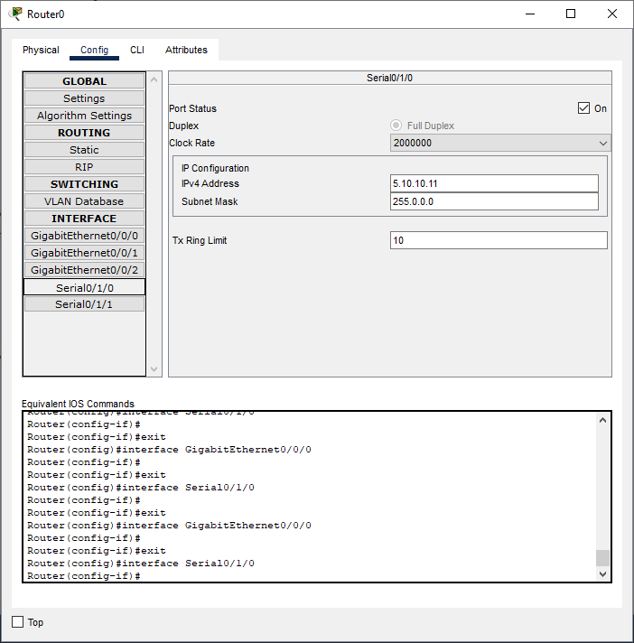

**Configuration of PC**

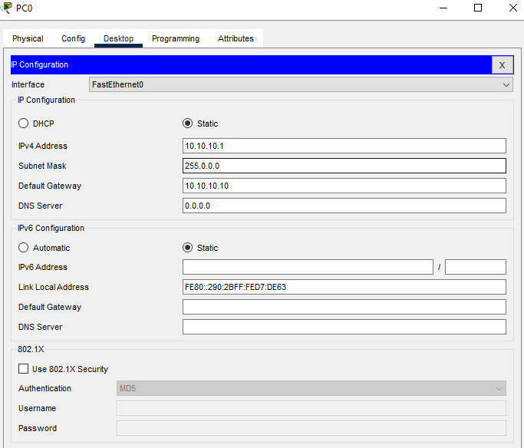

**Implementation of RIP protocol on the Router**

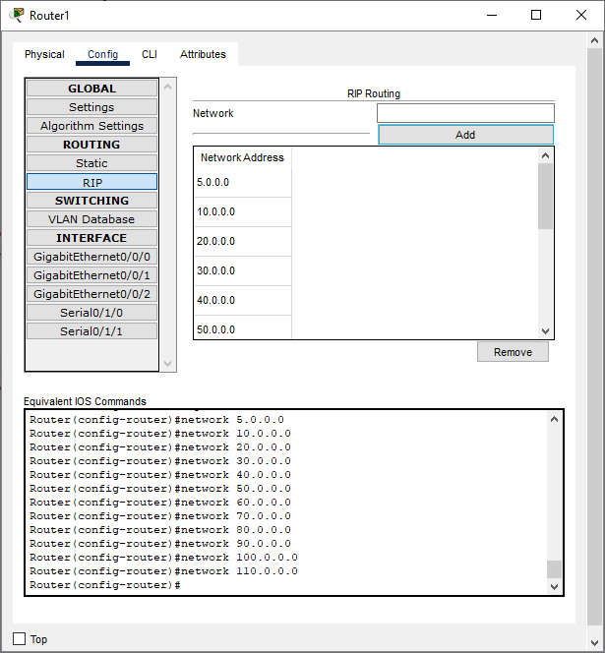

Follow the same procedure for Router 1, 2, 3, 4, 5.

**Verification of Connectivity**

Sending a Simple PDU from PC 110.10.10.1 to PC 30.10.10.1

**Step1:**

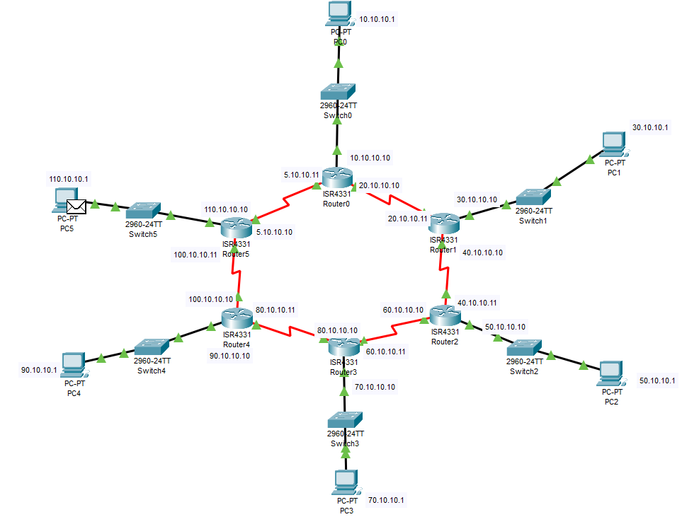

**Step2:**

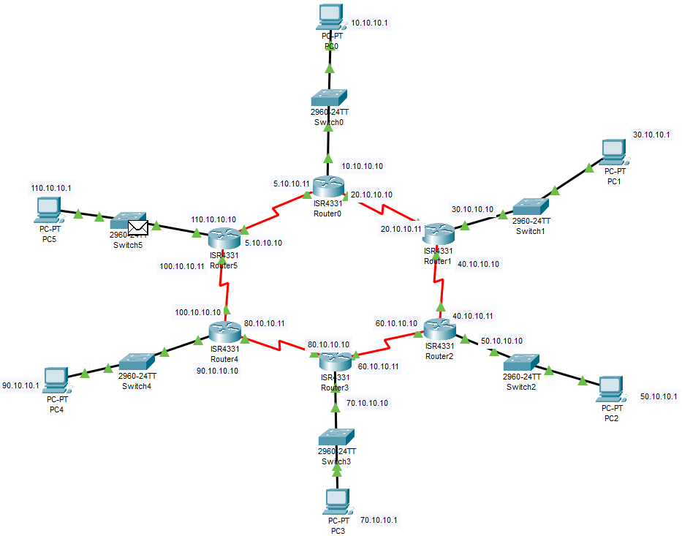

**Step3:**

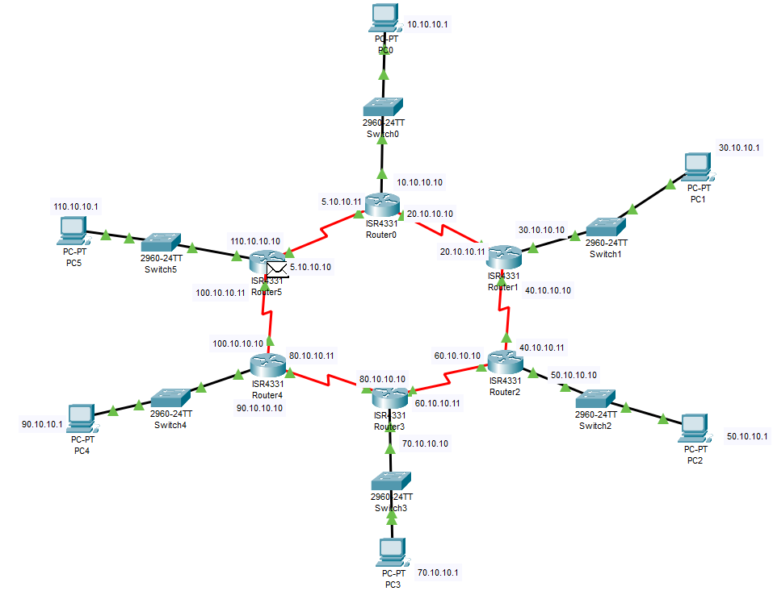

**Step4:**

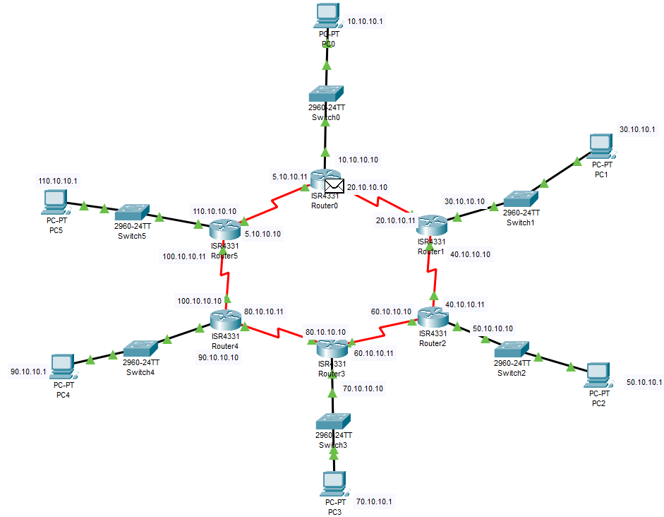

**Step5:**

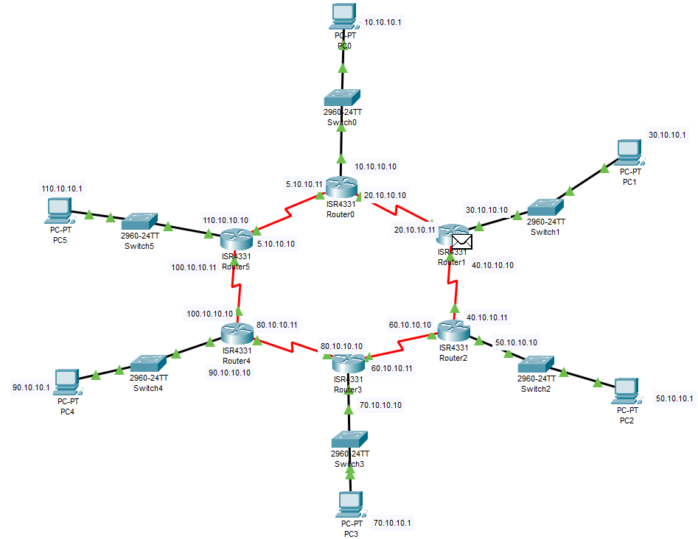

**Step6:**

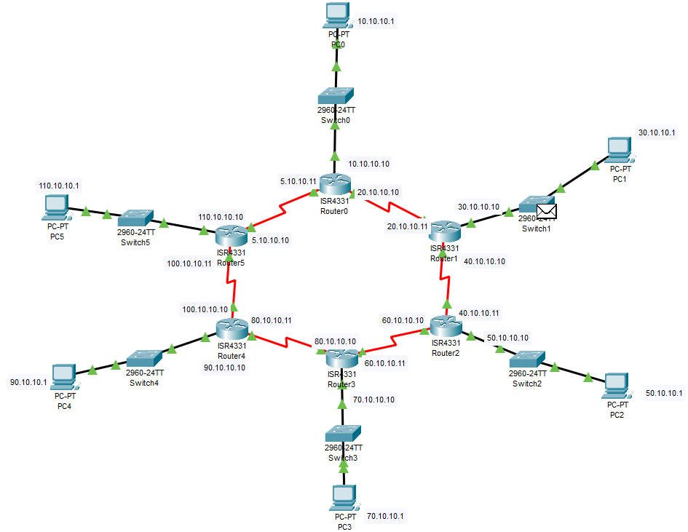

**Step7:**

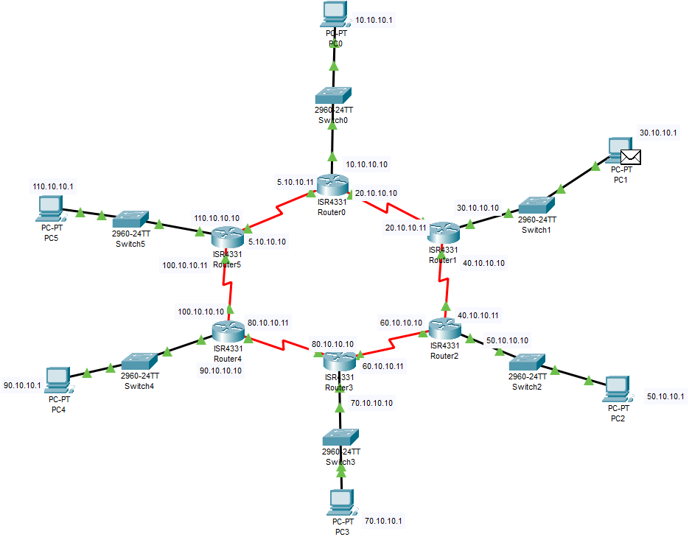

A Simple PDU was sent successfully from PC 110.10.10.1 to PC 30.10.10.1

**CONCLUSION:**

The Distance Vector Routing Algorithm in Networking also known as RIP (Routing Information Protocol) was studied, created and verified successfully.